**Study Summary, Project NeuroTeen Wave 2**

**DSN LAB, November 2017 – October 2018**

Contents

**Overview** 3

**Teen Session Overview** 5

**Pre-Scan** 5

Consent/Assent or Consent/Assent Review 5

Food Order 5

Questionnaire 5

Hair Sample 6

Training for Scanner & Scanner Games 7

Balloon Game [Balloon Analog Risk Taking (BART)] 8

Showing Prizes 9

Height 10

Weight 10

Computer Set Up: 10

Getting Teen into the Scanner: 10

**Scan** 10

Structural Scans (all acquired prior to the functional tasks) 10

*Localizer.* 10

*T1 MPRage.* 10

*T2 Matched Band Width.* 10

Scanner Tasks 12

*Commonalities across all Wave 2 Scanner tasks* 12

*Shapes Game* 13

*Ratings Game* 16

*Cups Game* 19

*Time Game* 22

*Classmates Game* 26

*Resting State* 33

**Post Scan** 33

Post Scan Survey 33

Time Game Task (Letter Stuffing/Free Time) 38

Pennies Game 39

Classmates Post Scan Task 43

**Description of Roles at the Session** 43

E1: 43

E2 43

**Parent Session Overview** 44

Additional Contact Info Sheet 44

MRI Screening Form 44

Hair Sample 44

Balloon Game 44

Ratings Game 44

Resource Sheets 45

Parent Questionnaire 45

**Participant Information** 45

Teen Transition Project 45

Recruitment 45

Inclusion & Exclusion Criteria 45

Overlap with Girls Health Study 46

Descriptives 46

*Racial, Gender, Ethnic Breakdown of Participants:* 46

*Participant Data Tracking* 46

**Study Measures** 46

NeuroTeen Measures (Teen) – Returning 46

NeuroTeen Measures (Teen) – New 46

TTP Measures 46

NeuroTeen Parent Measures – Returning 47

NeuroTeen Parent Measures – New 47

Different Teen Questionnaires administered 47

**Protocols** 47

Returning Families 47

New Families 47

Behavioral 47

SCAN LOG 48

TEEN CHECKLIST 48

PARENT CHECKLIST 48

**Data Management** 48

Preprocessing 48

**Syntax & Variable Names** 48

**Differences between Wave 1 and Wave 2** 48

# **Overview**

Project NeuroTeen is a 5-year longitudinal fMRI study grant awarded by NIDA to Dr. Eva Telzer. The grant is entitled, *Incorporating the Social Context Into Neurocognitive Models of Adolescent Risk Taking*. The overall goal of the study is to examine how three important social influences – family, peers, and authority – all differentially contribute to neurocognitive development and risk taking behavior. However, in this wave, the grant also studied prosociality, social reward, and neural encoding of social network position.

All participants were recruited from a small, low SES, diverse, rural community in North Carolina, an hour from Chapel Hill. This participant pool overlapped with Mitch Prinstein’s Teen Transition Project. In Wave 2 of the study, we recruited families that had participated in Wave 1 to return, and we also recruited new families. Like in Wave 1, completion of most of the Teen Transition Project’s Wave 1 survey was a prerequisite for participating in Project NeuroTeen Wave 2. However, teens did not have to have completed Wave 2 of the Teen Transition Study to participate. During recruitment, participants went through an extensive screening process. See below Inclusion and Exclusion Criteria for information on this.

Throughout the study, we employed three distinct protocols: returning family, new family, and behavioral session. The behavioral session protocol was only an option for returning families who were able to successfully scan in Wave 1 but had acquired some sort of temporary MRI contraindication between Wave 1 and Wave 2 (usually braces). We also were able to run a Spanish parent protocol, which entailed the same tasks and questionnaire but in Spanish.

Before the scan, new families were consented, while returning families simply reviewed their consent from the previous year and were provided with a copy. Teens were then instructed to work on their questionnaire and trained to perform all scan tasks in a training session. The experimenter obtained the teen’s best friend’s name as well as physical measures from teens (hair sample, height, weight). Participants also completed the Balloon Analogue Risk Task (BART) outside the scanner. Then, the teen went back to the scanner, where they completed five e-prime scanner tasks, a resting state scan, and structural scans (localizer, T1, T2).

Following the scan, we gave participants a meal from Brenz pizza. We provided food not just to the parent and teen, but also to any other members of the family also attending the session. If participants were not able to complete their questionnaire prior to the scan, they ate dinner while finishing the questionnaire. Otherwise, they ate while completing a post scan survey that asked them about the different strategies they employed during the scanner tasks. Then, participants completed a behavioral task from the Time Game (which entailed some combination of a break and stuffing envelopes to raise money for charity – more specifics below in the Time Game section), an E-Prime task called Pennies, and an E-Prime task that required participants to indicate liking/disliking for classmates they viewed in the scanner task Classmates.

Parents also completed a session with a second experimenter (E2). During their session, parents played two E-Prime tasks and completed a questionnaire.

Our payment structure varied depending on if the families were new or returning. New families were compensated $140 for their session, while returning families were compensated $165 for their session. All teens had the opportunity to earn extra money through the Cups game for themselves, their best friend, and their parent. As a reward for being still in the scanner and for completing all parts of the study, we offered teens one big prize and two little prizes. One of the big prizes was a $20 Walmart gift card, and so was another way to earn additional money. As all behavioral sessions were conducted with returning families, these families received the “Returning Families” amount.

Returning Families Payment:

* $50 for teen scan
* $20 for teen questionnaire
* $20 bonus for everything
* $30 for parent session
* $20 for parent’s gas
* $7.50 for parking
* $25 for returning family bonus
* Earnings during the Cups task given to the Teen (minus money lost on Pennies), to the Parent, and entrusted to teen to be given to the best friend

New Families Payment

* $50 for teen scan
* $20 for teen questionnaire
* $20 bonus for everything
* $30 for parent session
* $20 for parent’s gas
* $7.50 for parking
* $25 for returning family bonus
* Earnings during the Cups task given to the Teen (minus money lost on Pennies), to the Parent, and entrusted to teen to be given to the best friend

From 11/28/17 to 10/15/18, Wave 2 of the study was completed at the Biomedical Research Imaging Center (BRIC) at the University of North Carolina, Chapel Hill.

# **Teen Session Overview**

# **Pre-Scan**

### 

## Consent/Assent or Consent/Assent Review

The session began with E1 and E2 greeting the family in the lobby of the BRIC. Families were led either to the behavioral assessment room or one of the consent rooms (depending on what was available) in order to complete an assent and consent process. Before beginning this process, the experimenters offered families snacks (chips, goldfish, popcorn) and water.

For new families, E1 completed a complete assent and consent process. For returning families, E1 completed a review of the assent and consent process. For the “review,” families were reminded about participant privacy, the activities comprising the session, and payment for the session. They were given copies of their signed consents/assents from the previous year and told that they could keep them if they liked.

For the full consent process, E1 discussed participant privacy, the activities comprising the session, and payment for the session. First, E1 told parent and teen that everything that they would do at the session was safe and voluntary, and that their responses would never be shared. Parents were informed that some of their responses from the games might be shown to the teen, while their questionnaire responses were completely private. E1a then reviewed the activities comprising the parent and teen sessions, respectively.

E1 then explained payment. She informed families that we had a specific way of breaking down the payment based on the activities that each person completed at the session, but that ultimately, it was all money earned for the family. Participants were reminded that it was a longitudinal study, and that, not only would Project NeuroTeen invite them to participate each year, but also that they would receive $25 more each year they returned (so, $140 in Wave 1, $165 in Wave 2, and so on). Participants were also informed that teens could earn extra money through some of the games in the scanner as well as prizes (like headphones or speakers) for completing all parts of the study and staying still in the scanner. E1a showed the participant and their parent our Teen Checklist when indicating “all parts” of the study in order to underscore what “all parts” entailed.

After E1 answered any questions that the teen and parent had, teens signed their assent forms and parent signed their consent forms.

## Food Order

After the consent process/review, parent and teen were given a laminated menu of food options from Brenz pizza. They told E2 what they wanted, who recorded it and ordered it later during the parent session. Occasionally for early morning sessions or difficult families, we ordered Panera.

## Questionnaire

The first part of the teen session was the questionnaire, which teens began working on immediately after the parent and teen separated. Teens were given 30 minutes to work on the questionnaire before E1 asked the teen to move on. Most teens were able to finish the questionnaire during this time. However, if they did not, the teens were given additional time to complete the questionnaire as they ate dinner following the scan. The list of measures included in the Teen Questionnaire is listed below in the section entitled “NeuroTeen Measures (Teen).” Please also see the section that differentiates Wave 1 from Wave 2 measures.

In addition, E1 took the hair sample while the teen worked on their questionnaire. Some of the first measures in the questionnaire were the “Health Risk Behavior” (HRB) questions, which asked about drug use and sexual activity. To ensure that the teen did not feel “spied on” as they filled out these sensitive questions, E1 allowed the teen at least 3 to 4 minutes of time to work on the questionnaire before they began the hair sample. As an additional safeguard, E1 also assured the teen that we were busy with their hair and not able to see their responses.

## Hair Sample

Hair Samples were collected to measure pubertal hormones (testosterone, DHEA) and cortisol. Hair was always taken by sampling 2 cm below the posterior vertex of the head. The Posterior vertex was found by feeling for the part of the back of the head that stuck out the most. Here is a photo:

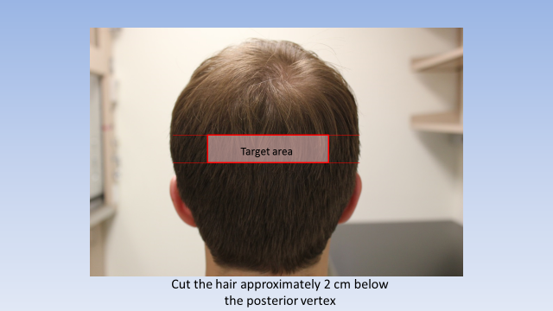

We used the comb to part the hair left to right along the posterior vertex. Then, fastened the hair away from the region using a clip. Hair was only sampled from the posterior vertex region of the scalp and not elsewhere. Once we separated a desired strand, we gently twisted the strand to hold it together. We used one of the pre-made loops of string to hold the hair together. Then, we slid the loop up to be about 1 inch away from the scalp and fastened. Then, we cut the hair with scissors as close to the scalp as possible. We pivoted the scissors to angle the blades in a manner that would not cut the participant’s scalp.

We always tried to take a thickness of hair equal to approximately the diameter of a pencil. To do this without making a small bald spot, we sampled from 3 different points along the scalp: left, center, and right. Each of the three samples were stored on a medium sized piece of aluminum foil, where they were taped down. At the top of the foil the participant’s ID was written: NT####-T/P (t or p depending on if it is the parent or the teen’s hair).

We obtained the hair sample while the teen completed their questionnaire at the beginning of the session. However, as noted above, we waited for them to get through the sensitive Health Risk Behavior questions before trying to get the hair sample (so the teens didn’t feel we were reading their answers to these questions).

## Training for Scanner & Scanner Games

We employed a training Power Point that can be found here: W:\NeuroTeen\tasks\Wave2\teen\NeuroTeen fMRI Task Instructions.ppt. This training power point reviewed what it was like to be in the scanner as well as instructions for each of the scanner tasks. The Power Point highlighted for teens the importance of staying still, how to use the button boxes, how to communicate with E1a while still in the scanner (e.g., via the intercom), and how they would be able to play games while scanning (e.g., by viewing a mirror allowing them to see images projected behind them).

The game portion of the Power Point reviewed the instructions for the Shapes, Ratings, Cups, Time, and Classmates games. We had a pair of button boxes identical to those used in the scanner that were given to the teens to hold during training. We had several “practice scenarios” interspersed throughout the Power Point to help the teens understand how to respond on the button box while playing the games. For example, during Time Game training, teens were asked, “if you wanted to select 8 minutes what would press?” to reinforce that 8 minutes was selected with the right ring finger. Throughout the game training, E1As exited the Power Point at points to complete a few different tasks. Those are listed below.

* Shapes Practice
  + During Shapes Training, E1a exited the Power Point to have participants play a “practice” version of the task in E-Prime. This task was identical to the real task EXCEPT for a few things: (1) Nim Tottenham’s face was used rather than the NIH faces that were used in the actual task, and (2) there were only 12 trials (4 reward, 4 punish, 4 neutral).
* Best Friend Questions
  + At the very beginning of Cups Training, participants were informed that they would play the Cups game on behalf of themselves, their parent, and their best friend. At this moment, E1 exited the training Power Point and opened what our lab referred to as the “Best Friend Questions” in Qualtrics. These were a slightly modified version of the NRI. We used the version of the NRI called “The Network of Relationships Social Provision Version – short form.” Participants answered about the parent who accompanied them to the session and the best friend whose address they had brought to the session.
* #1 Charity:
  + Prior to Time Game Training, E1a showed participants our Charity Ratings sheet. (Pictures of it are below in the Time Game section). E1a then read aloud to the participant the descriptions of 10 charities local to the county the teens were from, then asked them to indicate how much they cared about each charity on a scale of 1 (not at all) to 5 (very much). The teens then ranked the 3 charities they cared most about. Ultimately, the teens always stuffed envelopes for their number 1 charity. More details about this process can be found in the Time Game section below.

## Balloon Game [Balloon Analog Risk Taking (BART)]

Participants completed the well-established Balloon Analog Risk Task (BART; Lejuez et al., 2002), which involves sequential risk decisions in pursuit of rewards (e.g., money, points). The BART indexes risky behavior by measuring participants’ willingness to pump up a balloon in order to earn rewards; however, each sequential decision to pump up a balloon parametrically increases the risk that the balloon will explode and the subject will lose all the points they might have earned on that balloon. Behavioral performance and neural reactivity during the BART have been related to real-world risk-taking behaviors (Lejuez et al., 2002; Qu et al., 2015; Telzer et al., 2015), suggesting that this task captures externally valid components of real-world risky behavior.

During an instructional practice session, participants were told that the 3teens who scored the highest in the task would win an Amazon Fire Tablet. The task was self-paced and there were 45 trials.

This task was completed prior to the scan session.

Task Specifics:

* Number of trials:45 balloons
* The balloons werepresented in sequential order, with early balloons fixed to explode at later pumps so as not to discourage pumping behavior through the whole task.
* Eachballoon was presented with infinite duration, so that the task was self-paced
* Participants were told that balloons could explode any time after the first pump.However, the threshold for an explosion varied between 3 and 12 pumps.
* Balloons either increased in size or exploded with pump decisions
  + 1. If participants pumped past the threshold for that balloon, an explosion was presented with explosion sound: 1000 ms
    2. If participants cashed-out prior to explosion, the points they earned on that balloon were presented with a ringing sound that lasted 1000 ms and the total number of points displaying on the “Points Meter” increased
* Although the task was behavioral, it had a brief random jitter between 150 and 300 ms between each decision and the start of a new balloon.
* At the end of the game, the total number of points that the participant earned displayed for 5000 ms.

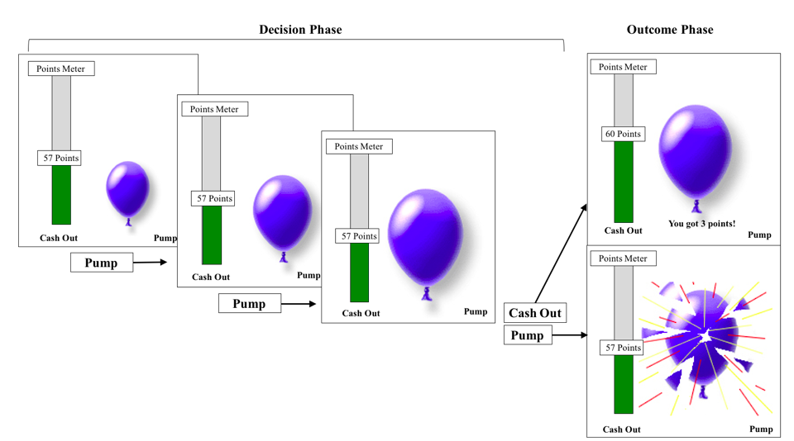

## Showing Prizes

Early in Wave 1, BRIC permitted us to keep the prizes for our participants in the top drawer of the mock scan room file cabinet. However, beginning in 4/16/18, BRIC began requiring us to use lockers to store our participant prizes. Please see the Wave 1 Study Summary for a description of how we showed participants the prizes in the mock scan room cabinet.

Following the change, we would show participants a bucket of prizes that we kept in the experiment room, before going to the prep rooms for height and weight. During consent, we mentioned briefly that participants would have the opportunity to earn prizes by completing all parts of the study and by holding still in the scanner. At this moment, E1 would call back to that and showed the teen all the prizes that we could offer them. It was again explained that, for completing all parts of the study and holding still in the scanner, they could take home 1 big prize and 2 little prizes. A big prize was a headphone, Walmart gift card (new in Wave 2) or speaker; a little prize was a candy or Gatorade. At this moment, E1 showed them their teen checklist with several items crossed off and said, “look, you’ve done so much already!”

Change for Scan

After E1 showed participants the prizes, she called the BRIC tech line to inquire if it was alright for herself and her participant to come back into Zone III. (BRIC’s policy is that any non-BRIC staff must call the tech line when entering Zone II or Zone III). E1 then went to the BRIC linen closet with the participant to get scrubs in their size, as participants were not allowed to wear street clothes in the scanner. If the participant was female and E1 was female, E1 asked the participant if there was any chance she could be pregnant at this time. If the participant was female and E1 was male, E1 asked another female at the session (either technologist, E1b, or E2) to ask the participant. We had to ask this because BRIC’s Policy is that pregnant females are not scanned for research purposes. After this, participants changed into their scrubs in the bathroom, used the bathroom, and had E1 lock their personal items in a locker. Participants were heartily encouraged to use the bathroom, as they were informed that we would have to rerun several scans if they got out.

## Height

Taken at BRIC, prior to the scan, using the mounted stadiometer at BRIC initially in the mock scan room, later moved to the prep room.

## Weight

Taken at BRIC, prior to the scan, using our own lab scale that was stored at BRIC initially in the mock scan room, later moved to the prep room.

## Computer Set Up:

E1b met E1 in Zone III. As E1 helped the participant get settled into their scrubs, she passed off the laptop to E1b to set it up for the scan. This process is detailed thoroughly in the protocol below.

## Getting Teen into the Scanner:

The BRIC technologist was responsible for getting teens in the scanner. While they did this, E1a worked with E1b to finalize computer set up. The techs were instructed to give all teens a pillow under the legs and padding under their arms. Techs also applied a piece of tape to the foreheads of teens to help reduce motion.

# **Scan**

## Structural Scans (all acquired prior to the functional tasks)

### *Localizer.*

### *T1 MPRage.*

* The T1 lasted 6.5 min. Teens watched Pixar Videos during this time.

### *T2 Matched Band Width.*

* The T2 lasted 1 min. Teens watched Pixar Videos during this time. Below are detailed instructions that were provided to the BRIC techs in order to achieve the acquisition desired.

Below is a picture of a good T2 Acquisition. We want to ensure the angle is oblique, such that it is angled from the bottom of the OFC to the bottom of cerebellum. This is usually about a 20 degree angle, but that totally depends on participants’ position in the head coil and can be 0 degree angle or more than 20 degrees.

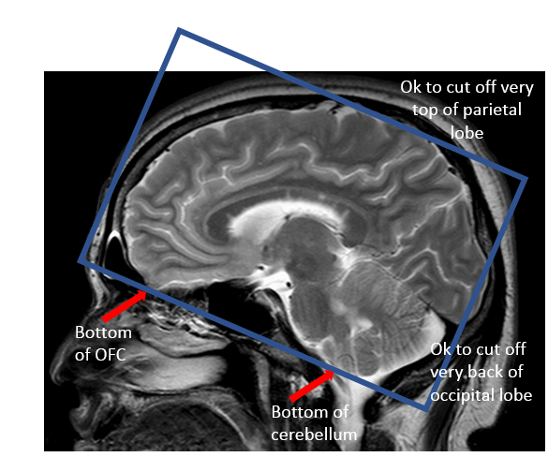

Once the angle is correct, move the field of view (the box) to optimize brain coverage. Ideally, the full brain is in the field of view, but if their head is large, prioritize the frontal lobe and temporal lobe. Very top of parietal lobe and back of occipital lobe can be cut off if needed.

The best way to ensure that the temporal lobe and frontal lobe are not at all cut off prior to acquiring the T2 is to bring up the T1 and flip through the slices with the T2 field of view box. If anything will be cut off, the tech should ask you if what’s being cut off is ok. The bottom of the temporal lobe is very important, so scrolling through the T1 with field of view will ensure it isn’t cut off. The image below shows an example of a good and bad acquisition.

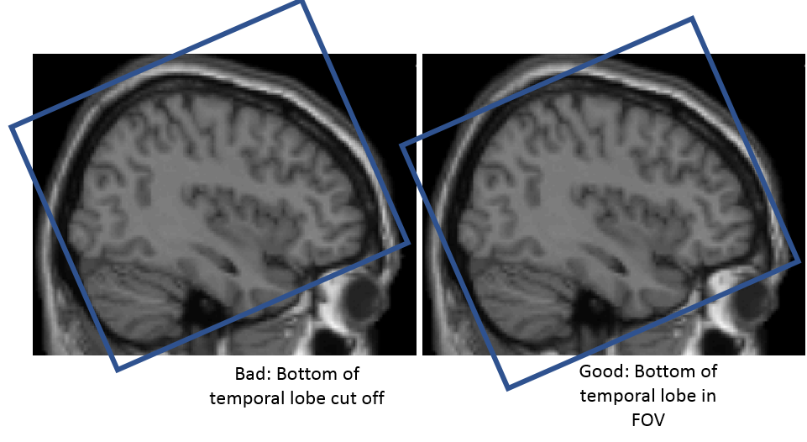

Finally, there is one last check you can do. After the T2 is acquired, the axial view of the T2 will pop up on the tech’s screen. If the T2 is done well, you should see NO BRAIN in the very bottom slice of the axial view.

Scanner Tasks

*Commonalities across all Wave 2 Scanner tasks*

* E1 instructional reading
* Across all scans, E1 read the ScanLog to participants. The ScanLog contained instructions for each different task in the scanner. E2 ran the computer during the scan and was tasked with advancing the E-Prime task at a pace that matched what E1 was reading, such that each slide corresponded to what E1 was telling the participants. See the Wave 2 ScanLog (below in this document) for these instructions.
* Button Boxes
  + During the Scan, all participants responded to the tasks using a button box held in their right and left hands, respectively.
  + Here is a picture of the right hand button box, as well as an example of how participants were instructed to hold it (e.g., with one finger on each button)
    - 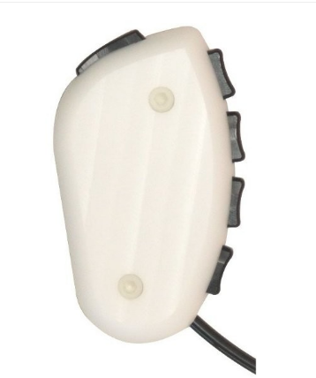 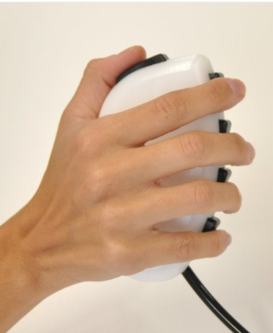
  + Participants were shown a picture of hands indicating what buttons they should be pressing throughout the game. See below for an example of what this would have looked like for the Ratings Game. However, the exact “hand slide” differed depending on what buttons were required for each particular game. Photos of these hand slides are contained in the task specific sections below.
* Each scanner task began with the following slides: Welcome, Hands, Additional Instructions (if needed), Trigger, Get Ready
* Welcome to the XXX Game!
* Duration: infinite - advance with space bar
* Example photo:
* 
* Photos of hands with the buttons necessary to press during that game highlighted in blue
* Duration – infinite – advance with space bar
* Example photo:
* 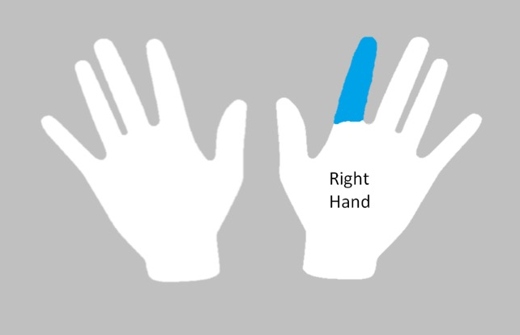
* Additional Instructions (optional)
* Duration – infinite – advance with space bar
* Trigger
* Upon seeing the trigger screen, which was a “ +” on a black background (or grey background for Shapes only), E1b (computer operator) told the scan tech to start the scan
* In E-Prime, the trigger advances with an “o”
* Example photo:
* 
* Get Ready
* Duration: 4000 ms. Note in Wave 1 this was messed up and was 8000 ms but we fixed it in W2.
* Example photo:
* 

*Shapes Game*

This is the Social Incentive Delay Task (SID). It is designed to measure neural sensitivity to anticipation of and receipt of social rewards and punishments.

In the task, teens see a circle, a square, or a diamond. Then, they see a white square. They are trained (prior to entering the scanner) to press their right index finger as fast as they can after seeing the white square, but not before! During the training completed prior to the scan, they learn that each shape is a cue, which indicates whether or not they will see a happy, angry, or blurred face depending on how quickly they press. Our participants are explicitly told during their training that the circle is a happy cue, the square is an angry cue, and the diamond is a neutral cue. This means that if they press fast enough after seeing the circle, they will see a happy face; if they press too slow after the circle, they will see blurred face. If they press fast enough after seeing the square, they will see a blurred face; if they press too slow after the square, they will see an angry face. Because the diamond is a neutral cue, they will see a blurred face after the diamond--no matter if they press fast or slow. The below photo provides a visual depiction of these instructions.

The faces are photographs of other teens taken from the NIH faces dataset. In the task, there were 24 faces shown (12 female, 12 male). Some of the faces were of children, some of teens. There were 58 trials in the task, and the pictures could repeat. However, the way in which the pictures could repeat depended on the participant’s response. For example, if the participant pressed slowly on a Reward trial for the face F1, and then slowly again on a Neutral trial for the face F1, the participant would see a blurred version of the face F1 on the reward trial and the same blurred version of the face F1 on the neutral trial. In contrast, if the participant pressed quickly on the Reward Trial they would see a F1 making a Happy face.

Photo depicting task instructions:

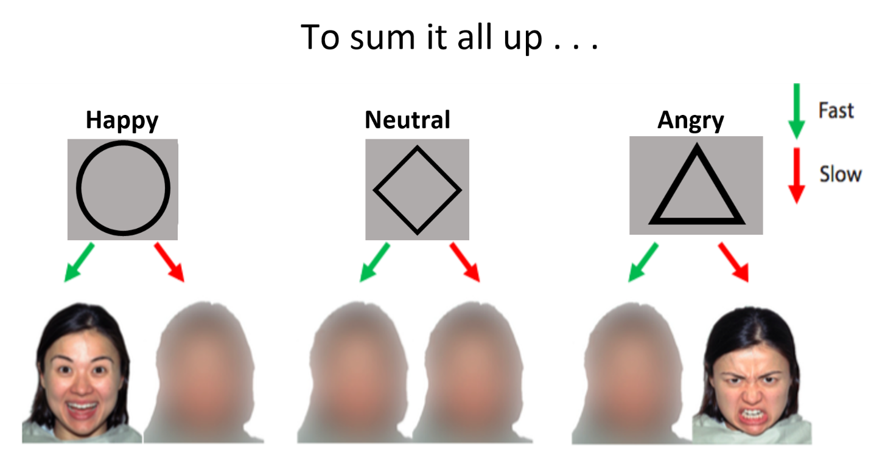

Task Specifics

* The game had all the same intro slides as listed above: Welcome Slide, Hands slide (sliding indicating what fingers to use in the task), Additional Instructions (needed for Shapes, shown below), Trigger slide, Get Ready slide
* The Hands slide for the Shapes game was indicated that participants needed to press only with their right pointer finger in this game. See below.
  + 
* There was an additional instructions slide for Shapes. It reminded participants of the meaning of the circle, diamond, and triangle. See below for photo.
  + 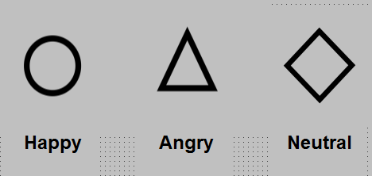
* The task has 2 rounds. Each round of the task lasted 6.5 minutes, 13 minutes total.
* Each of the 2 rounds consists of 58 trials.
  + Round 1 consists of 24 Circles (Reward trials), 24 Triangles (Punishment trials), and 10 Diamonds (Neutral trials). Round 2 also consists of 24 Circles, 24 Triangles, and 10 Diamonds.
* The task has an event-related design. Each of the cues (circle, diamond, or triangle) was presented in a random order across each round of the task.
* *Events and duration of events*

1. Cue (the shape—a circle, a diamond, or a square): 500 ms
2. A fixation cross: jittered, see jitter information
3. The target – a filled-in, white square: 300 ms
4. A delay (a blank screen): 50 ms
5. Feedback (smiling face, angry face, or blurred face): 1450 ms
6. A 2nd fixation cross: jittered, see jitter information

* *Fixed-pace or self-paced*
  + Adaptive Timing: for each correct target response (i.e., pressing for the white square within the allotted time), the task would adjust the target duration on the subsequent trial to be 20 ms shorter (making the task more difficult). Conversely, for each failed target response (i.e., failing to press for the white square within the allotted time), the task would adjust the target duration on the subsequent trial to be 20 ms longer (making the task less difficult). The duration for the target was bounded at 500 ms at the upper limit and 160 ms at the lower limit.
* *Jitter information*
  + In this task, there are two types of jitters, the “anticipate” jitter and the “feedback” jitter. The anticipate jitter follows the cue and the feedback jitter follows the feedback.
    - *Anticipate Jitter:*
      * Minimum: 480.6596929
      * Maximum: 3883.210254
      * Mean: 2008.601
    - *Feedback Jitter:*
      * Minimum: 509.671062
      * Maximum: 4249.399729
      * Mean: 2303.885
* A note about the task: all participants played a practice round of the Shapes task during training prior to the scan. The practice task was structured identically to the regular task except for two key distinctions: 1) the practice task contained only Nim’s face (while the real task contained faces from the NIH Faces dataset) and 2) there were only 12 trials in the practice task.

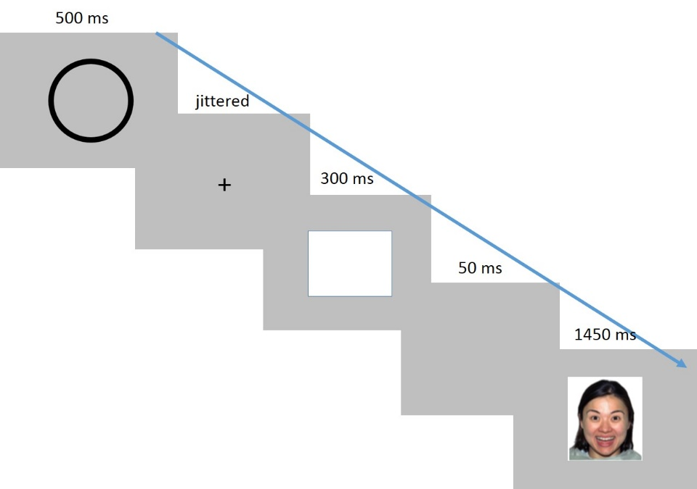

*Ratings Game*

This task assesses teens’ perceptions of their parents’ and peers’ attitudes regarding different negative behaviors. These are the same behaviors that parents rate in their session in Ratings-parent. 40 teens in our prior SCAND study rated the items. This task allows us to examine the difference between what teens think their parents/peers think and what they actually think.

During the task, teens rate the same behaviors their parents rated, using the same 1-10 scale. However, instead of rating just how good or bad THEY think the behaviors are, they also rate how good or bad they think their parent and their peers think that these behaviors would be. The teens are rating on behalf of the parent at the session (not both parents). We tell the teens that the peers they are rating for are “other kids in your grade at school.”

Task Specifics:

* The game had all the same intro slides as listed above: Welcome Slide, Hands slide (sliding indicating what fingers to use in the task), Additional Instructions (NOT needed for Ratings), Trigger slide, Get Ready slide
* The Hands slide for the Ratings game indicated that participants needed to press with all ten of their fingers to rate behaviors on the 0-9 scale. See below.
  + 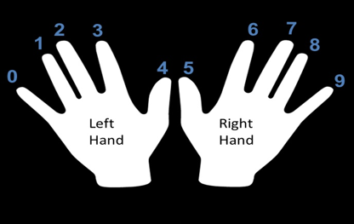
* This task consisted of two rounds. Each round took 8 minutes, creating a 16 minute task.
* The teens rated the behaviors on behalf of their parent, their peers, and themselves in blocks.
  + Within a round, there were six blocks, 2 each for parent, peer, and self, which were presented in a random order.
  + Each block contained 12 unique behaviors (trials) for the teens to rate.
* In each round, there were 24 parent trials, 24 peer trials, and 24 self trials. Thus, there were 72 trials per round, 144 trials across the entire task.
* The teens rated each of the 48 behaviors on behalf of their parents, peers, and themselves.
* The 48 behaviors rated were:

1. Blaming a sibling in order to get out of trouble
2. Buying something their parents would not approve of
3. Cheating on exams
4. Copying someone else's homework
5. Cursing
6. Disrespecting a teacher
7. Ditching school early
8. Faking being sick to avoid going to school
9. Fighting with their parents
10. Forging their parents’ signatures
11. Hanging out with friends their parents don't approve of
12. Hooking up with their date in a movie theater
13. Ignoring their parents' phone calls or texts
14. Letting a friend copy their homework
15. Lying about completing chores
16. Lying to their parents about bad grades
17. Lying to their parents about where they are going
18. Picking on their siblings
19. Sneaking into somewhere off-limits
20. Sneaking out of the house
21. Staying out past curfew
22. Stealing from a store
23. Talking back to authorities
24. Throwing a party without their parents' permission
25. Cheating on a boyfriend or girlfriend
26. Drinking alcohol at a party
27. Driving in a car without a seatbelt
28. Driving without a license or permit
29. Getting a ride from a drunk driver
30. Getting a tattoo
31. Getting into a fight with a friend
32. Going bungee jumping
33. Gossiping about a friend
34. Having sex with multiple partners
35. Having sex with someone they just met
36. Having unprotected sex
37. Hitch-hiking
38. Playing with fireworks
39. Punching or hitting someone
40. Saying mean things to their peers
41. Sending a sexual text
42. Skydiving
43. Smoking a cigarette
44. Smoking marijuana
45. Speeding through a yellow light in the car
46. Spreading a rumor at school
47. Texting while driving
48. Walking alone in an unsafe area

* *Presented in a fixed or random order:* 
  + Random
* *Events and duration of events*
  + Same for Parent, Peer, and Self blocks:

1. Screen indicating the type of block (Parent, Peer, or Self): 4000 ms
2. Fixation cross: jittered, see jitter information
3. Behavior appears: 5000 ms; screen advances when participant makes response
4. A Too Late! screen if participant doesn’t respond within 5000 ms: 1000 ms

* *Fixed-pace or self-paced*
  + Self-paced
* *Jitter information*
  + Minimum: 1284.8 ms
  + Maximum: 3435.1 ms
  + Mean: 2232.558 ms

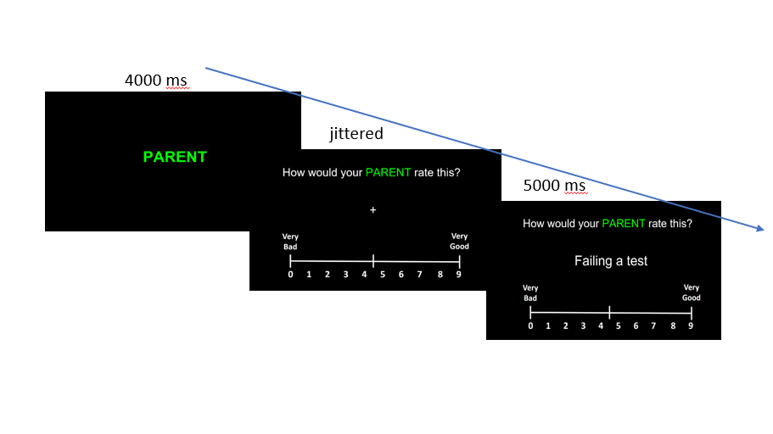

*Cups Game*

The Cups Game measures risk-taking in the context of monetary rewards. The task has been used in prior studies of adolescent risk taking (e.g., Galvan & McGlennen, 2011; Levin, Hart, Weller, & Harshman, 2007), during which adolescents make decisions in the context of a sure outcome or unsure outcome. Prior research has only examined this in the context of rewards for the self. In our SCAN’D project, we modified the task such that participants played for their parent or self (Guassi Moreira & Telzer, in press). In NeuroTeen, we modified the task, such that adolescents made decisions in the context of their best friend, self, and parent.

In the recruiting process and in the phone and email reminders leading up to the scan, we asked parents to remind their teens to bring the address of their best friend from school to the session. Parents were told that we asked for this information because teens would play a game for their best friend and write a note to their friend following the session about the game. During training, we surprised the teens by telling them that the reason why we asked for their best friends’ address was that they would be playing a game in which they would earn money on behalf of their best friend, which we would then mail to their best friend. Following this surprise, they completed the NRI about their best friend and the parent that they came to the session with. (It was explained that they would earn the money for the parent at the session, not the other parent).

Using data from this task, we are able to compare neural responses when taking risks that affect different important individuals in the teens’ lives: the parent, the best friend, and the self. Participants earn money during the task, and any earnings they win are paid in cash at the end of the session. The parent is given the money the participant earned for them, the participant is given their earnings, and the money for the best friend is placed in an addressed envelope, in which the participant writes a quick note to their best friend. This is then mailed directly to the best friend following the scan.

During the task, participants see cups on the screen. A vertical line divided the row of cups into a left side with one cup and a right side with many cups (either 2, 3, or 5). Participants were told that 15 cents was always hidden beneath the single cup on the left side, whereas 30, 45, or 75 was hidden beneath one of the many cups on the right side. Participants were instructed to pick between the two sides and were told that the computer would then randomly select a cup from the chosen side. The teens were taught that if they pressed with their right index finger, the computer would pick up a cup on the right side of the line. If they pressed with their left index finger, the computer would pick up a cup on the left side of the line. Therefore, choosing the left side was associated with a 100% probability of gaining 15 cents whereas choosing the right side contained a 50%, 33% or 20% probability of gaining a result greater than 15 cents (30, 45, or 75). The game is cumulative within each round. Participants played 3 separate rounds: parent, best friend, self. This order was counterbalanced across participants. Parents were not made aware prior to the task that their child was completing a round of the task for them. The reward for the parent was delivered to them in front of the adolescent at the end of the study session and included in the envelope containing their other payment for the session ($20 for gas, $30 for session).

Task Specifics:

* The Cups game had all the same intro slides as listed above: Welcome Slide, Hands slide (slide indicating what fingers to use in the task), Additional Instructions (needed for Cups), Trigger slide, Get Ready slide
* The Hands slide for the Cups game indicated that participants needed to press with their right pointer finger to have the computer pick up a cup on the right side of the line, and with their left pointer finger to have the computer pick up a cup on the left side of the line. See below for a photo of that slide.
  + 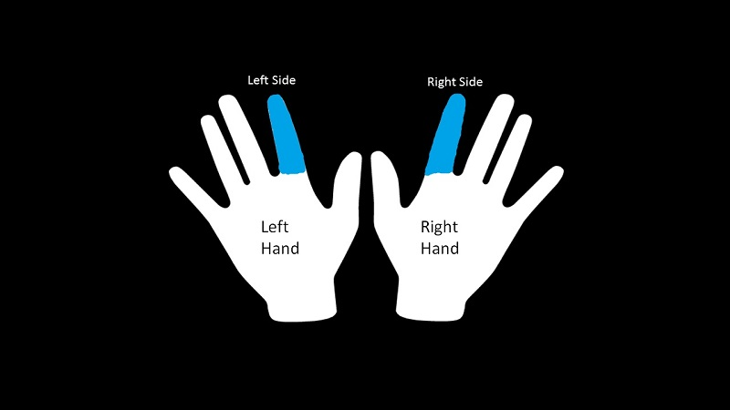
* The Cups game did have an additional instruction slide. It reminded participants for whom they were playing. Below is a photo of that slide from the Self round of the task. The text for this slide was different for the Parent and Best Friend rounds of the task.
  + 
* *Number of trials:* 
  + 48 per round; across Parent, Best Friend, and Self, the teens played 48(3) = 144 trials
* *Presented in a fixed or random order:* 
  + Random
* *Events and duration of events*

Same for all 3 rounds: Best friend, Parent, and Self

1. A fixation cross: jittered, see jitter information (inter-trial jitter)
2. Stimulus Image (one cup on the left and 2, 3, or 5cups on the right) and Decision: 3000 ms
3. Fixation screen, see jitter information (feedback jitter)
4. Feedback (the amount of money under the cup chosen): 1000 ms

* *Fixed-pace or self-paced*
  + Self-paced
* *Jitter information*
  + Feedback Jitter
    - Minimum: 521.1359015 ms
    - Maximum: 3913.314 ms
    - Mean: 2521.393 ms
  + Inter Trial Jitter
    - Minimum: 526.6792 ms
    - Maximum: 4017.124 ms
    - Mean: 2300.012 ms

See below for a diagram depicting the structure of the task. The diagram shows the Self round of the task. In Best Friend and Parent rounds, the task looked exactly the same except the text “Self” was replaced with “Best Friend” and “Parent.”

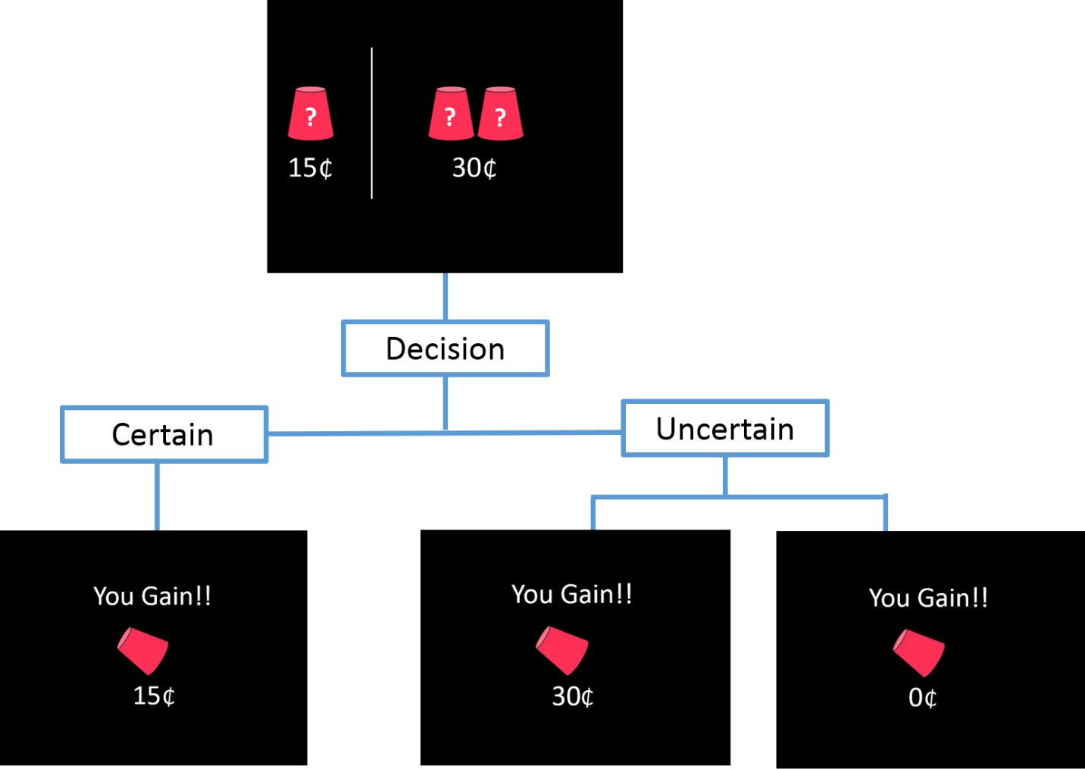

### *Time Game*

The Time Game looks at brain activation during prosocial choices. In the Time Game, participants have the choice to donate some of their time to specific charities. In contrast to Wave 1, in which there were three rounds of the Time Game (Play, Evaluate, and Play), in Wave 2, there was only one round of the Time Game (Play).

Immediately following the scan, teens could take a ten minute break. During the Time Game, teens chose how much of their ten minute break they wanted to donate to a good cause.

During training, teens were told that our lab supports the county that the teens are from and had teamed up with several local good causes. Teens were shown the NeuroTeen Charity Ratings Sheet (inserted below), and E1 read aloud each charity’s goal to the teen. (These goals can be seen below on the Charity Ratings Sheet too; they are visible beneath the charity logo). E1 then asked the teen to fill out the sheet, first filling out the “how much do you care about this cause?” column, (marking the number between 1 and 5 that corresponded to how much they cared) and second, ranking the three charities that they care most about.

**NeuroTeen Charity Ratings Sheet**

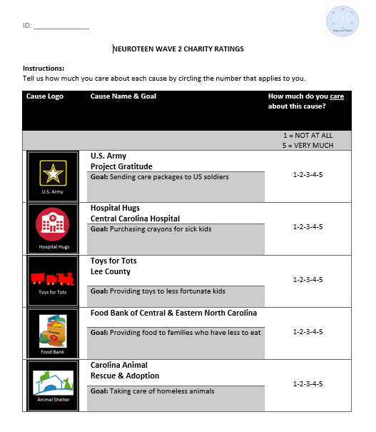

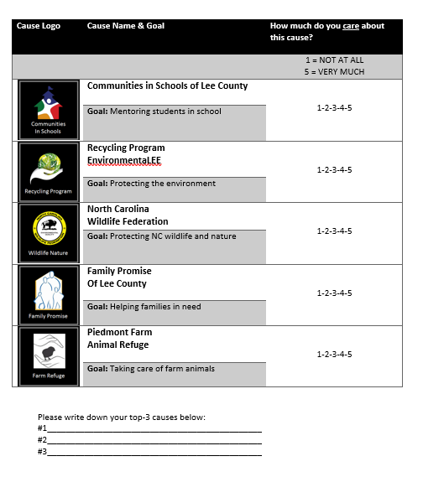

After completing the Charity Ratings Sheet, teens were told more about the Time Game. It was explained that if they decided to donate some of their break time to charity, they would spend some of the 10-min break putting pre-written, fundraising letters in envelopes. We showed them a set of plastic drawers in the room that contained the letters they would stuff into envelopes. Each drawer was affixed with a charity logo and contained 50 pre-typed letters designed to raise money for a specific charity. We explained that if they decided to spend no time helping they would get a full 10-min break where they could complete a fun activity. The fun activities included an iPad with games, Jenga, snacks, adult coloring books, gel pens, a mini basketball hoop and ball, brain teaser puzzles, and an actual brain puzzle.

During the Game, one good cause (logo and name) was presented on the screen, and the teen had to decide how many minutes – between 0 and 9-- to contribute. During training they were told: “The computer will randomly select only one trial out of all the trials you play. This will be the time you will spend stuffing envelopes to raise money for a good cause. The time you spend helping can be between 0 and 9 minutes in total. You don’t have to stay any extra time!” The game was not cumulative. Teens used their button box to select the number of minutes they wanted to give to each charity when the charity and its logo were presented on the screen.

At the end of the scan, the Experimenter selected a single trial, and that was how many minutes the teen would then donate. The trial was selected by opening the Time Game e-dat and scrolling to the 16th row in the e-dat. Then, E1a scrolled down until she found the #1 charity picked by the teen on their charity ratings sheet. She then scrolled across to the Stim.RESP column to find how many minutes were donated for that charity. In this way, teens always stuffed envelopes for their number one charity.

Task Specifics:

* *Number of trials:* 
  + 40 trials within each round, 120 trials total

*Presented in a fixed or random order:*

* + Random within a run, but the run order is fixed.
* *Events and duration of events*

Round 1: Play

1. Welcome to the Time Game: infinite
2. Hands: infinite
3. Trigger
4. Get Ready for Round 1: Play: 8000 ms
5. A fixation cross with rating scale from 0 – 9 (How many minutes would you like to contribute?): jittered, see jitter information
6. Stimulus (image and name of charity), participant makes a decision: 3000 ms max, trial advances when participant makes a decision
7. A delay: 10 ms
8. Choice Screen (teen’s choice circled on the rating scale): 500 ms
9. Too Late! Screen if participant does not respond within the 3000ms decision screen: 1000 ms
10. Done Round 1 screen: 4000 ms

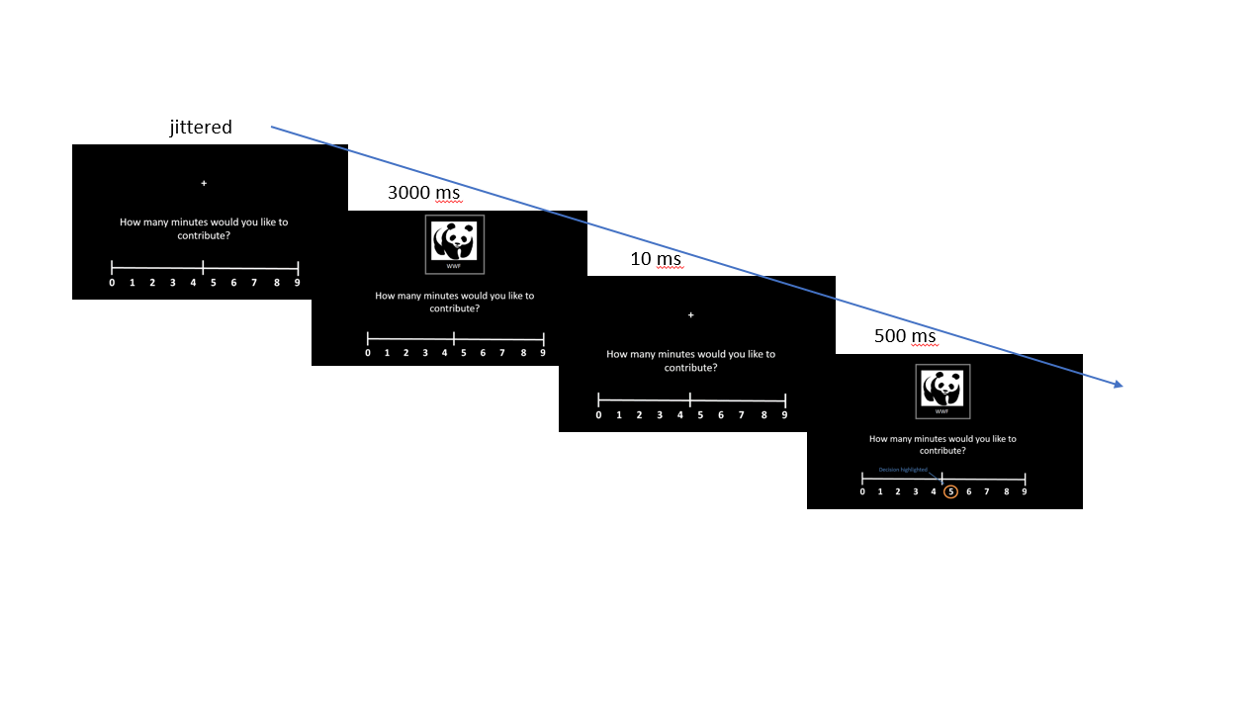

### *Classmates Game*

This task was based on work conducted in Carolyn Parkinson’s *Nature Human Behavior* (Parkinson, Kleinbaum, & Wheatley, 2017). That paper asks the question, “what information about others’ social network position is activated spontaneously?” In her study, all first year students in Dartmouth College’s MBA program completed a brief questionnaire about their social network. Dr. Parkinson then recruited a subset of MBA students for an fMRI study, in which she showed participants short videos of other MBA students. In her analyses, she examined how “social distance” (e.g., how close participants were with one another) was visible at the neural level.

Our task takes these ideas a step further. Rather than just having information about social closeness, our data are enriched by the sociometric data in Mitch Prinstein’s Teen Transition Project dataset. In that study, all participating students completed a sociometric survey which required them to respond to the following questions:

* Who do you like the most?
* Who do you like the least?
* Who is the most popular?
* Who is the least popular?

The sociometric survey was conducted by school by grade, and then its results were translated into Z-scores. These Z-scores allowed us to quantitatively examine the most popular, most liked, least popular and least liked teens by grade at each school. Having this data about all Teen Transition participants enabled us to examine not only how social position is encoded at the neural level, but also how social status within a single grade at a school is encoded at the neural level among teenagers.

For the Classmates Game, there were 6 different versions—a 6th and 7th grade version for each of the three schools in the Teen Transition Project. Each individual task had four conditions: Most Liked, Least Liked, Most Popular, and Least Liked. Within each condition, there were 10 teens, and we aimed for an equal mix of boys and girls within each condition. (We tried for 5 boys, 5 girls per condition, but this was not always possible; some conditions have 4 and 6 or 6 and 4). Further, we did not simply select the teens with the ten highest (or lowest) sociometric scores within a school and grade because we tried to ensure equal distributions of sociometric scores across schools and across conditions. For example, at one of the middle schools, the most popular teen had a z-score of 9; yet, the most popular teens at the other schools had scores closer to 5.5 or 6. The argument could be made that seeing a teen with a popularity z-score of +9 is different from viewing a teen with score of 6, even if both teens are the “most popular” in the 7th grade at their respective schools.

To be selected for the most popular or most liked category, the teen needed to have a z-score in the given category such that, 1 < x < 5, where x was the z-score. To be selected for the least popular or least liked category, the teen needed to have a z-score in the given category such that, -1 < x < -5, where x was the z-score. All averages were approximately 2 standard deviations away from the mean in the appropriate direction. (That is, 2 below for “least” categories, 2 above for “most” categories). Additionally, there was no overlap across conditions. (For example, a teen in WL6 Most Popular category could not also be shown in WL6 Most Liked category). Further, NO NeuroTeen participants were shown in the Classmates Game because we did not want participants to see themselves.

Below is the full distribution of z-scores of each teen selected to be in each of the tasks, by school, by grade. These can also be found in the tasks themselves, and they can also be found in the document on the secure server: Y:\NeuroTeen\Classmates Game\SchoolGradeSchoolName_Attributes_Final.xlsx. (There is a separate spreadsheet for each grade and each school).

**WL6 Distribution**

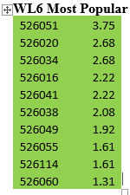 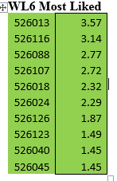 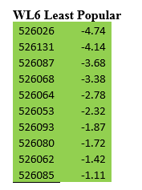 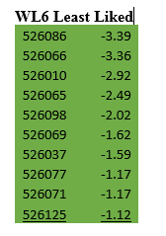

**WL6 Averages:**

Popularity Avg High: 2.207998692

Popularity Avg Low: -2.7164778

Likability Avg High: 2.307

Likability Avg Low: -2.085

**WL7 Distribution**

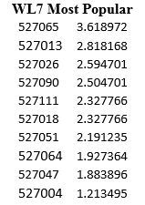 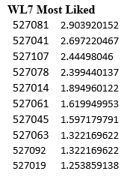 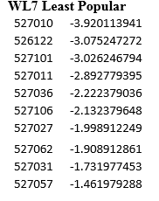 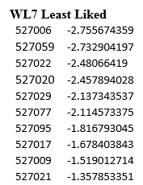

**WL7 Averages:**

Popularity Avg High: 2.340806381

Popularity Avg Low: -2.437093

Likability Avg High: 1.945584946

Likability Avg Low: -2.105112

**EL6 Distribution**

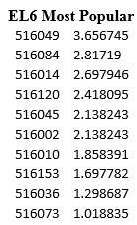 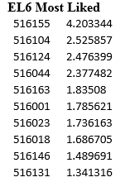 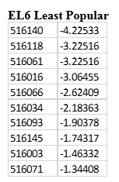 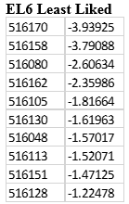

**EL6 Averages**

Popularity Avg High: 2.17401564

Popularity Avg Low: -2.500227

Likability Avg High: 2.145765674

Likability Avg Low: -2.500227

**EL7 Distribution**

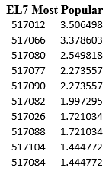 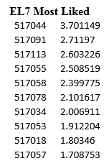 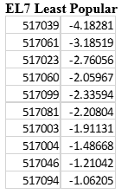 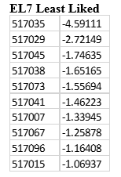

**EL7**

Popularity Avg High: 2.231094134

Popularity Avg Low: -2.240268

Likability Avg High: 2.345758448

Likability Avg Low: -1.856146

**SL6 Distribution**

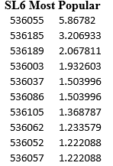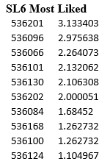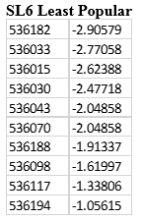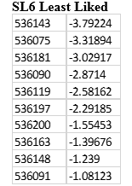

**a note on SL6 most popular condition: it says above that we aimed to always have every z-score below the absolute value of 5. In the case of SL6 Most Popular, the average would have been a 1.7 (too low compared to the other groups). Because we did not allow TTP participants to be in multiple conditions, there was no one else to replace this teen with. We decided to choose to have one most pop z-score above 5 rather than have an average below 2.

**SL6 Averages**

Popularity Avg High: 2.11297004

Popularity Avg Low: -2.080215

Likability Avg High: 1.99264872

Likability Avg Low: -2.315675

**SL7 Distribution**

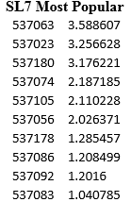 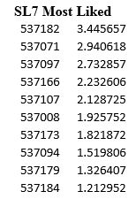 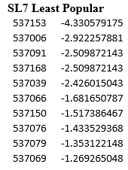 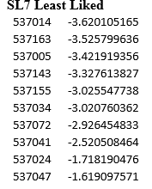

**SL7 Averages**

Popularity Avg High: 2.132625306

Popularity Avg Low: -2.195355

Likability Avg High: 2.128725282

Likability Avg Low: -2.195355

Beneath each question in Qualtrics was a list of all the teens in the student’s grade at their school. Using this data, Z-scores were created to reflect sociometric popularity (likability) and perceived popularity (popularity). For the purposes of the Classmates Game, there were 4 conditions: most liked, least liked, most popular, and least popular, all based on the Z scores in the TTP dataset.

The photos displayed in the task were yearbook photos. Mitch Prinstein’s Project Coordinator obtained the yearbooks from the schools on behalf of our lab. Although Project NeuroTeen was conducted during the 2017-2018 school year, the most recent yearbook came from 2016-2017, so teens saw photos of their classmates that were approximately one year old.

To digitize the photos in order to put them in the task, we took individual photos of the yearbook picture of each teen selected to be in the task. These photos were taken using a Samsung Galaxy s7. The phone was positioned 2 7/8 inches away from each photo using a 9 oz plastic cup that was 2 7/8 inches tall. The phone rested on top of the cup when taking the photo, allowing us to take each photo of the yearbook picture at equal distance. When taking the photo, the “flash” option was not used. Instead, we used a desktop lamp to illuminate the photos.

Each photo was then uploaded from the phone to a computer, cropped, and transformed into a JPEG image. These images were then processed to improve quality. First, the location of eyes in each face was matched, so that these were in the same location across pictures. Then, a Gaussian blur was applied to eliminate the pixelated appearance of the photos that stemmed from taking them so close up. Next, we attempted to match the background color within school and grade in order to increase consistency. Finally, within school and grade, each photo was resized to be the exact same JPEG dimensions. For example, in the West Lee 7 task, all photos are all 405 x 540. These steps were taken in Photoshop and Matlab.

Finally, after each teen was selected and their yearbook photo was digitized and processed, we underwent a rigorous checking process to ensure that: the TTP ID and name of the teen selected match, the TTP ID assigned to the photo (as this was how they were identified) matched the teen’s name on their picture, and that the likability and popularity scores were accurate. Once this was done, we were ready to program the task!

Overall, there were 6 tasks—one for each grade at each school. In terms of programming the task, the first task that was programmed was West Lee 7. This became the “base task,” meaning that others were used to program from this one once it was complete.

The structure of each task was the same. The task was broken into 2 rounds. Each round consisted of 2 blocks, such that there were 4 blocks total within the task. Each block consisted of 4 conditions: most liked, least liked, most popular, and least popular. Within each block, the order in which these 4 conditions appeared was randomized. Further, within each condition, there were 10 teens chosen to comprise that condition based on their sociometric scores (as described above), and the order in which their faces were shown was also randomized. The random order within condition was based on their sociometric scores. In order to get the randomization, I entered the numbers 1 – 10 into a random number generator 16 times. In each condition, the number 1 represented the person who was number 1 in that category (e.g., number 1 most liked person in that school in that grade) and the number 10 represented the person who was the 10th (e.g., number 10 most liked person in the school in that grade).

Similar to Carolyn Parkinson’s task which contained an N-Back to ensure that the participants were paying attention, we included duplicate pictures within each condition. So, within each condition within each block, each participant saw the same face twice in a row. When this happened, they were instructed to press with their right point finger, which was done to ensure that they were paying attention. The faces that were chosen to be duplicates were fixed in the task.

Diagram:

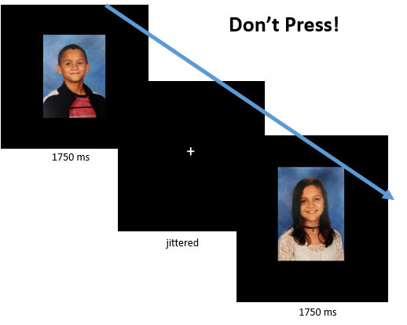

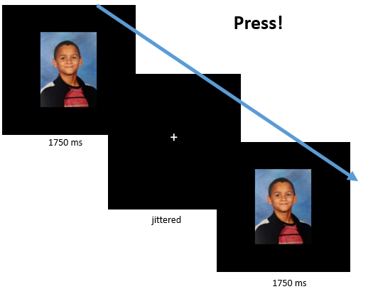

### *Resting State*

We acquired Resting State for 8 minutes during Wave 2. During Resting State, participants were instructed to lie still and look at a white fixation cross on a black background and try not to fall asleep. Resting State was the very last scan and generally the first thing to “get cut” from the protocol during Wave 2, so not all teens have it.

# **Post Scan**

## Post Scan Survey

After the scan, participants were served their dinner and instructed to work on their post scan survey while they ate. The post scan survey asked participants about their experiences playing the different games in the scanner. For returning teens who completed behavioral sessions, we still asked them to complete the post scan survey because many of the questions asked the teens about their behavior – not necessarily the scan itself. Unlike in Wave 1 where we used two versions of the Post Scan survey, only one version was used throughout Wave 2 of NeuroTeen.

That version has been copied and pasted in below.

**Wave 2 Post Scan NeuroTeen Questionnaire**

(For experimenter to enter) What is this participant's 6-digit ID? ________________

Think back to your experience playing the Shapes Game. . .



Was this a happy, angry, or neutral cue?

* happy
* angry
* neutral



Was this a happy, angry, or neutral cue?

* happy
* angry
* neutral



Was this a happy, angry, or neutral cue?

* happy
* angry
* neutral

When you were playing the Shapes Game, how did you feel when you saw the . . .

|  |  |  |  |  |  |
| --- | --- | --- | --- | --- | --- |
|  | Very Bad (1) | 2 | Neutral (3) | 4 | Very Good(5) |
| triangle |  |  |  |  |  |
| circle |  |  |  |  |  |
| diamond |  |  |  |  |  |

|  |  |  |  |  |
| --- | --- | --- | --- | --- |
|  | Not at all (1) | A little bit (2) | Somewhat (3) | Very much (4) |
| How motivated were you to SEE the happy faces? |  |  |  |  |
| How motivated were you to AVOID SEEING the angry faces? |  |  |  |  |

These next questions will ask about your experience playing the Cups Game.

While you were playing the Cups Game . . .

|  |  |  |  |  |
| --- | --- | --- | --- | --- |
|  | Not at all (1) | A little bit (2) | Somewhat (3) | Very much (4) |
| How motivated were you to win money for your parent? |  |  |  |  |
| How motivated were you to win money for your best friend? |  |  |  |  |
| How motivated were you to win money for yourself? |  |  |  |  |

|  |  |  |  |  |  |
| --- | --- | --- | --- | --- | --- |
|  | Very bad (1) | A little bad 2 | Neutral 3 | A little good (4) | Very good (5) |
| How did you feel when you selected a cup and WON money for your parent? |  |  |  |  |  |
| How did you feel when you selected a cup and WON money for your best friend? |  |  |  |  |  |
| How did you feel when you selected a cup and WON money for yourself? |  |  |  |  |  |

Who did you try to win the most money for (you, your parent, or your best friend)? Explain why.

Did your strategy change depending on if you were playing for yourself, your parent, or your best friend?

These next questions will ask you about your experience playing the Time Game.

|  |  |  |  |  |  |  |  |  |  |  |
| --- | --- | --- | --- | --- | --- | --- | --- | --- | --- | --- |
|  | Not at All (1) | 2 | 3 | 4 | Some (5) | 6 | 7 | 8 | 9 | Very Much (10) |
| How much did you enjoy giving your time (donating > 0 minutes) to help good causes? |  |  |  |  |  |  |  |  |  |  |
| How much did you enjoy keeping time to yourself (donating 0 minutes)? |  |  |  |  |  |  |  |  |  |  |
| How excited were you to stuff envelopes for a good cause? |  |  |  |  |  |  |  |  |  |  |
| How excited were you for the fun activities during the break for the Time Game |  |  |  |  |  |  |  |  |  |  |

What was your strategy to decide whether you wanted to give or not give time?

Did you think that the activities we had were more fun than stuffing envelopes?

* Yes
* No

|  |  |  |  |  |  |  |  |
| --- | --- | --- | --- | --- | --- | --- | --- |
|  | Very Negative (1) | 2 | 3 | Neutral (4) | 5 | 6 | Very Positive (7) |
| How do you feel about volunteering activities at this moment? |  |  |  |  |  |  |  |

## Time Game Task (Letter Stuffing/Free Time)

After completing the post scan survey and eating their dinner, participants completed the Time Game Task. During training, participants were told that following the scan all teens got a ten minute break and that they could choose to donate some of their ten minute break to charity if they wanted. See the scanner tasks section on the Time Game task above for how the number of minutes the teens donated was determined. Teens always played for their number one charity.

To begin the task, E1 set out a stack of fundraising letters and a stack of envelopes. Participants were reminded of the break time and the decisions that they made during the Time Game in the scanner. They were told, “the computer selected the following decision: X mins for [name of charity]. This means you will be spending X mins of your break time stuffing envelopes and X minutes doing a FUN activity.”

Teens were asked to please stuff as many envelopes as they could during the allotted time. They did not have to seal or address the envelopes. They just had to stuff the envelopes one at a time. (In other words, they were asked to fold a letter and then insert it into the envelope instead of folding several and then beginning to put them in the envelopes). E1 then set a timer for the number of minutes the teen donated and left the room.

Once that number of minutes was up, E1 went back in the room to tell the teen to stop stuffing. E1 then told the teen how many minutes they had remaining for their fun activity, reminding the teen of all the fun activities we have left out for them (e.g., iPad, adult coloring books, etc). E1 again set a timer for the remaining time and left the room, taking the envelopes the teen stuffed with them. Outside the experiment room, E1 counted the number of envelopes the teen stuffed while the teen completed their break time.

Following the session, E1 removed the letters from the envelopes and recycled them. The envelopes were put back in our locker and reused at later sessions. The letters were never mailed anywhere.

## Pennies Game

The Pennies Game is based on research by Diana Tamir and her lab at Princeton, which demonstrates that disclosing information about oneself is inherently rewarding and that people will actually pay/forgo money to do it. Our Pennies task was modified from the Tamir Lab’s work. The goal of the task was to measure adolescents’ willingness to see the ratings of their parent and their peers. The task quantitatively measures how much teens value knowing what their parents and peers think of different taboo or bad behaviors that teens their age might engage in.

In the task, teens have the opportunity to pay (using the money they earned during the Self round of the Cups Game) to learn what their parent and their peers actually rated during the Ratings Game. The parent ratings were taken from the ratings the parent provided during their session. The peer ratings were taken from data acquired from teens during the SCAND study. During the SCAND study’s Opinions Task, participants provided ratings for 288 different behaviors. The 48 behaviors selected for display in this study (and in Teen and Parent Ratings) are the behaviors that had the most variability among the ratings.

In the Pennies task, the teens can choose to either see or skip viewing their peers’ or parent’s ratings. This task was completed following the scan session and following completion of the questionnaire.

Each choice--SEE or SKIP—was paired with an amount of money between 1 and 4 cents. Following Tamir & Mitchell (2012), we calculated every permutation of pairs of values that could appear on the left option (See) vs. the right option (Skip). Specifically, there were:

* 6 possible pairs where the LEFT value > RIGHT value (.04/.03; .03/.02; .02/.01; .04/.02; .04/.01; .03/.01)
* 6 possible pairs where the LEFT value < RIGHT value (.03/.04; .02/.03; .01/.02; .02/.04; .01/.04; .01/.03);
* 4 possible pairs where the LEFT value = RIGHT value (.04/.04; .03/.03; .02/.02; .01/.01)

The frequency of each pair of values followed a uniform distribution, such that each pair of values appeared 3 times, totaling 48 trials per block (or 6 times, totaling 96 trials across parent and peer blocks). The pairs of values were randomly assigned to SEE vs. SKIP options for each participant.

Given the uniform distribution, the total amount that participants can pay to always See vs. always Skip is equal. These are the total amounts (in cents) that participants can lose based on the strategy they use during the Pennies task:

* If participants always chooses to See, they can lose 480 cents total across Parent and Peer blocks.
* If participants always chooses to Skip, they can lose 480 cents total across Parent and Peer blocks.
* If participants always choose the option (See or Skip) that minimizes the loss, they can lose 360 cents total across Parent and Peer blocks.
* If participants always choose the option (See or Skip) that maximizes the loss, they can lose 600 cents total across Parent and Peer blocks.

At the end of the task, participants are shown how much they chose to pay to see their parent’s/peers’ ratings. The total is manipulated so that participants do not lose too much of their bonus money from the visit, with the hope of increasing participant retention over the years while still holding them somewhat accountable for the real costs of their decisions. As a result, the outcome was manipulated to be one of the following options: 1.00, 1.05, 1.10, 1.15, 1.20, 1.25. Outcomes were rounded to the nearest nickel to make this feasible with bringing money to the scan. Thus, we subtracted anywhere from $1 to $1.25 from the participant’s Cups Self winnings.

The specific values impact our ability to calculate how much participants are willing to pay for social influence. If participants intrinsically value knowing how their parent (or peers) think, they should be willing to pay (i.e., incur a monetary loss) to find out what their parents' (or peers') ratings are. On the other hand, participants were free to minimize their monetary loss by consistently choosing whichever option (see vs. skip) cost the least amount, irrespective of the opportunity to find out what their parents' (or peers') ratings were. The relative value of learning what their parents (or peers) think about various behaviors will be modeled by (1) first calculating the point of subjective equivalence (PSE) between the two option types (SEE vs. SKIP), and then (2) comparing the PSE of the parent vs. peer blocks. For each block, the PSE value will be derived by fitting a cumulative normal distribution curve to each participant’s choices and finding the monetary value at which a participant effectively chooses arbitrarily (50/50 chance) between the two option types. Thus, the PSE represents the relative monetary value (in cents) of SEEING over SKIPPING their parents' (or peers') ratings of various taboo behaviors. In addition to the PSE, we can also look at the total monetary value (cents) that participants paid to See vs. Skip their parents' (or peers') ratings to index how much learning their parents' (or peers') opinions was worth (in cents).

Excitingly, we can then examine whether the relative value of learning their parents' (or peers') attitudes predicts the magnitude of parent (or peer) influence on adolescents' own evaluations of these behaviors. In order to operationalize the latter, we can calculate the difference between their (pre)rating on the Self block of the Ratings game in the fMRI and their (post)rating after viewing what their parent (or peer) rated on the Parent (or Peer) block of the Pennies task) for each behavior, and then average across all behaviors for a global "susceptibility to parent (or peer) influence" score per participant.

During the task, the participants see these 48 behaviors (below) twice—once during the peer block, once during the parent block. The 48 behaviors were taken from the Opinions Task run in SCAN’D. Again, these 48 behaviors were selected because, in Opinions, ratings for these behaviors had the most variability.

|  |  |  |
| --- | --- | --- |
| Behavior | Behavior Number | Opinions Behavior Number |
| Blaming a sibling in order to get out of trouble | 1 | 159 |
| Buying something their parents would not approve of | 2 | 160 |
| Cheating on exams | 3 | 161 |
| Copying someone else's homework | 4 | 163 |
| Cursing | 5 | 183 |
| Disrespecting a teacher | 6 | 167 |
| Ditching school early | 7 | 173 |
| Faking being sick to avoid going to school | 8 | 187 |
| Fighting with their parents | 9 | 147 |
| Forging their parents’ signatures | 10 | 165 |
| Hanging out with friends their parents don't approve of | 11 | 157 |
| Hooking up with their date in a movie theater | 12 | 184 |
| Ignoring their parents' phone calls or texts | 13 | 155 |
| Letting a friend copy their homework | 14 | 164 |
| Lying about completing chores | 15 | 192 |
| Lying to their parents about bad grades | 16 | 158 |
| Lying to their parents about where they are going | 17 | 149 |
| Picking on their siblings | 18 | 154 |
| Sneaking into somewhere off-limits | 19 | 189 |
| Sneaking out of the house | 20 | 150 |
| Staying out past curfew | 21 | 153 |
| Stealing from a store | 22 | 176 |
| Talking back to authorities | 23 | 188 |
| Throwing a party without their parents' permission | 24 | 156 |
| Cheating on a boyfriend or girlfriend | 25 | 50 |
| Drinking alcohol at a party | 26 | 44 |
| Driving in a car without a seatbelt | 27 | 45 |
| Driving without a license or permit | 28 | 43 |
| Getting a ride from a drunk driver | 29 | 65 |
| Getting a tattoo | 30 | 62 |
| Getting into a fight with a friend | 31 | 80 |
| Going bungee jumping | 32 | 49 |
| Gossiping about a friend | 33 | 83 |
| Having sex with multiple partners | 34 | 74 |
| Having sex with someone they just met | 35 | 52 |
| Having unprotected sex | 36 | 51 |
| Hitch-hiking | 37 | 66 |
| Playing with fireworks | 38 | 64 |
| Punching or hitting someone | 39 | 84 |
| Saying mean things to their peers | 40 | 77 |
| Sending a sexual text | 41 | 72 |
| Skydiving | 42 | 61 |
| Smoking a cigarette | 43 | 56 |
| Smoking marijuana | 44 | 57 |
| Speeding through a yellow light in the car | 45 | 55 |
| Spreading a rumor at school | 46 | 79 |
| Texting while driving | 47 | 59 |
| Walking alone in an unsafe area | 48 | 68 |

Task Specifics:

* *Number of trials:* 
  + 96 – 48 peer trials, 48 parent trials
  + Each of the 48 trials comprises a round.
  + There were two blocks—one for peer, one for parent. The block that came first was determined via counterbalancing written on E1’s checklist before each session.
* *Presented in a fixed or random order:* 
  + Whether the peer or parent block comes first is fixed. The presentation of each of the 48 behaviors is random within each round.
* *Fixed pace or self-paced?*
  + Self-paced
* *Events and duration of events:*
* Parent Round
  + Parent Choice – teen can decide to see or skip parent rating of behavior: infinite
  + If teen chooses to see, parent rating revealed to teen: 5000 ms
    - Note: this is the actual parent rating of the behavior.
  + If teen chooses to skip, hashtag appears where the rating would have been: 5000 ms.
  + While viewing the parent rating (or no rating), teen rates the behavior with their own opinion again, which allows us to examine if their decision has changed (from the scan) based on seeing the opinions of their parent (or peer).
  + Too Late! – If teen is too slow when rating the behavior with their own opinion again, a “Too Late!” screen will appear: 1000 ms
* Peer Round
* Same thing as Parent Round for Peer Round
  + Note: Peer Round displays average ratings teen participants made during SCAN’D Opinions Task as described above

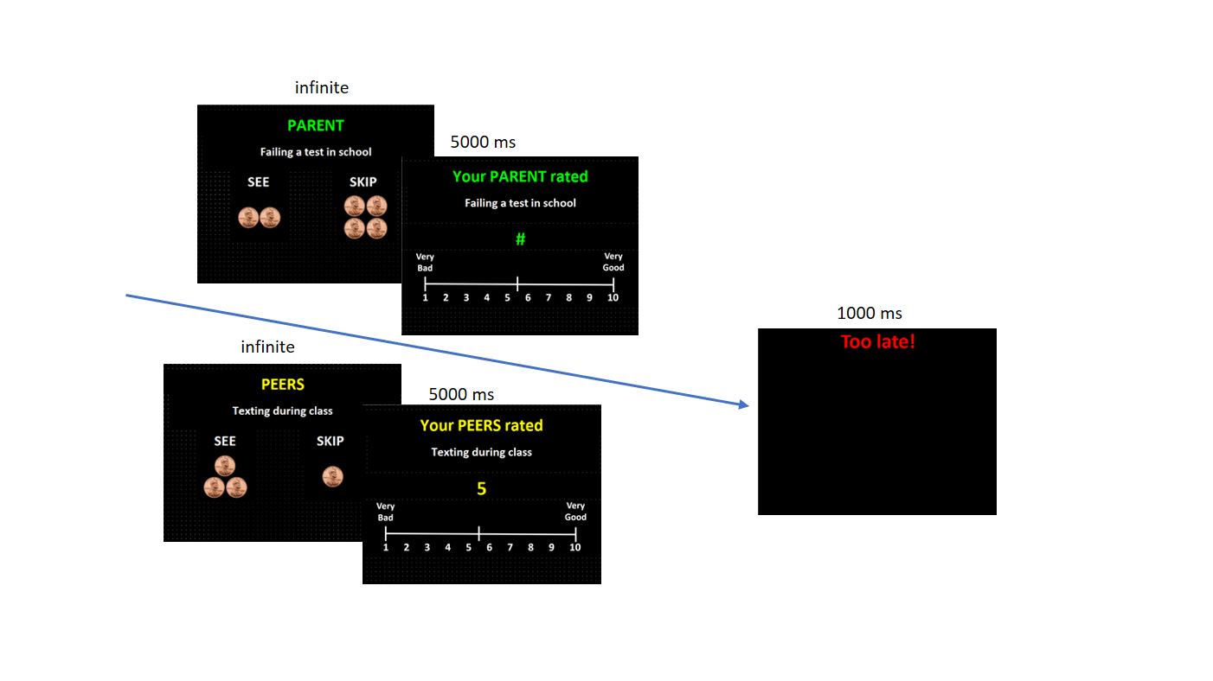

## Classmates Post Scan Task

# **Description of Roles at the Session**

## E1:

E1 was the teen experimenter. She worked with the teen and had to stay for the duration of the visit. She was responsible for packing the suitcase for the visit, training the teen, the teen tasks , teen physical measures, the success of the scan, talking to the teen at the scan, paying the family, the post scan clean up, and returning everything from the scan properly.

## E2

E2 was the parent experimenter. She had responsibility for the parent tasks, parent hair sample, parent questionnaire, running the computer at the scanner, as well as ordering, retrieving, and setting up food for teen and parent. She was also responsible for making sure that the parent was happy at each session. She also was responsible for running the computer during the teen’s session. She was able to do this because, during Wave 2, we had the parents complete their questionnaire in the lobby alone rather than with an experimenter. We gave them a card with the Google Voice number on it to call if they needed anything and to alert us when they were done with the questionnaire.

# **Parent Session Overview**

*note – for parent session, all items were completed in the order below

## Additional Contact Info Sheet

## MRI Screening Form

BRIC required us to go over an MRI safety form about the teen with the parent. Although we complete a safety screener over the phone with the family before they are scheduled, BRIC asks that we have the parent fill out this screener on the day of the session as well. The parent completes this form with the parent experimenter. Then, approximately 30 minutes before the scan, the parent and the parent experimenter go back to the MRI room to go over this form with the scan tech.

## Hair Sample

Same instructions as for teen

## Balloon Game

This was the same game as for the teen, except for the fact that we told the parents that only 1 parent out of all the parents that participated would be able to win an Echo Dot by getting the highest score on the game.

## Ratings Game

Parents are told that in the scan their child will read statements about behaviors that teens their age might do and they will rate how good or bad each behavior is. We ask the parents to also rate those same behaviors on a scale of 0 (Very Bad) to 9 (Very Good). Parents used an external keypad to make their ratings. Again, these were the behaviors that the teens rated during their scan in the Teen Ratings Game. Also, these were the 48 behaviors out of 228 that received the most variable ratings in the Opinions Task from the prior SCAN’D study.

## 

Task Specifics

* *Number of trials:* 
  + 48
* *Presented in a fixed or random order:* 
  + Random
* *Events and duration of events:*
  + 1. Rating— parent rates behavior: infinite
    2. End game— after all 48 trials are rated, parents see “Thank you!” screen: 2000 ms
* *Fixed-pace or self-paced:* 
  + self-paced
* *Jitter information –*none, behavioral task

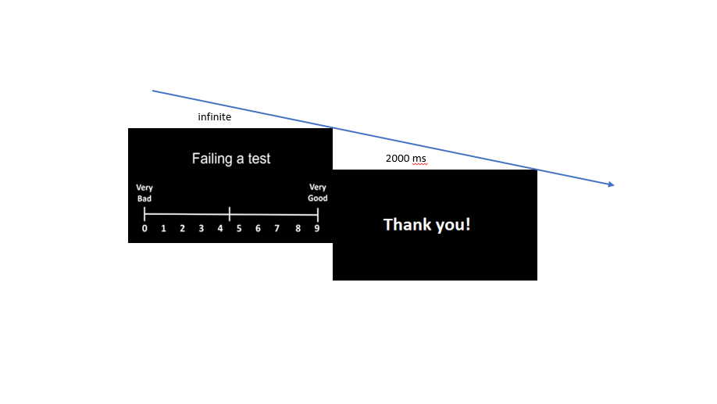

## Resource Sheets

## Parent Questionnaire

See below the measures that were obtained for the parent questionnaire.

# **Participant Information**

## Teen Transition Project

Discuss W2 TTP here

## Recruitment

Discuss W2 Recruitment here

## Inclusion & Exclusion Criteria

To be eligible participants had to be at least 12 years old, or within two months of turning 12. They must have been a part of the TTP study in its first wave.

Participants were excluded if they had braces, a permanent top retainer, or some kind of permanent dental work at the time (metal). Other exclusion criteria were as follows:

* Is your child claustrophobic (afraid of being in small, confined spaces)?
* Does your child have any metal in his/her body that cannot be removed (e.g., piercings, metal rods from a corrective surgery, etc)?
* Does your child have a weave?
* Has your child ever been diagnosed with a learning disability, such as dyslexia?
* Has your child ever had a seizure?
* Has your child had head trauma, like a blow to the head that resulted in a loss of consciousness?

Teens with parent-reported ADHD, ADD, and ODD were allowed in the study only if they agreed to do a 24 hour med wash – take medication normally, but 24 hours prior to coming in for the MRI we would ask that they didn’t take it. Left handed participants were included.

## Overlap with Girls Health Study

## Descriptives

### *Racial, Gender, Ethnic Breakdown of Participants:*

### *Participant Data Tracking*

# **Study Measures**

## NeuroTeen Measures (Teen) – Returning

## NeuroTeen Measures (Teen) – New

## TTP Measures

* HEQ
* HRB
* LKE
* PDS
* IRI
* PTM
* PSRT
* SRQ
* IMP
* RPI
* SSMC
* DOSPERT
* SMFQ
* SASA – SUS triad
* ERQ
* Alexithymia
* Liked Most
* Liked Least
* Most Popular
* Least Popular
* Prosocial Peers
* Most Easily Influenced by Other Peers
* Peer group Norms
* LONE
* NSSI
* Suicide
* RSQ

## NeuroTeen Parent Measures – Returning

## NeuroTeen Parent Measures – New

## Different Teen Questionnaires administered

# **Protocols**

## Returning Families

## New Families

## Behavioral

## SCAN LOG

Can be found on server here: Z:\NeuroTeen\organization\Wave2\session_materials\folder_documents

## TEEN CHECKLIST

Can be found on server here: Z:\NeuroTeen\organization\Wave2\session_materials\folder_documents

## PARENT CHECKLIST

2 different versions – one including the additional contact info sheet, one not

Can be found on server here: Z:\NeuroTeen\organization\Wave2\session_materials\folder_documents (new)

Z:\NeuroTeen\organization\Wave2\session_materials\folder_documents\archive (old)

# **Data Management**

## Preprocessing

# **Syntax & Variable Names**

To see a table depicting all the syntax and variable names for all of the questionnaires used in this study, please refer to:

# **Differences between Wave 1 and Wave 2**

* In Wave 1, we got hip/waist. In Wave 2, we didn’t
* Wave 1: questionnaire done after the scan; Wave 2: questionnaire was the first thing teens work on
* Wave 1: Pictures. Wave 2: cut Pictures; instead, employed Classmates game
* Wave 1: 3 rounds of Time game (Play, Observe, Play); Wave 2: 1 round of Time (play only)
* Wave 2: Classmates post scan task
* Wave 2: Lockers, Wave 1: Mock Scan Prize drawer